Pain Diary
Patient Name:
Date of Procedure:
Procedure:
Pain 1. Location/ Description (X):
Pain 2. Location/ Description (0):
Pain 3. Location/ Description (-):

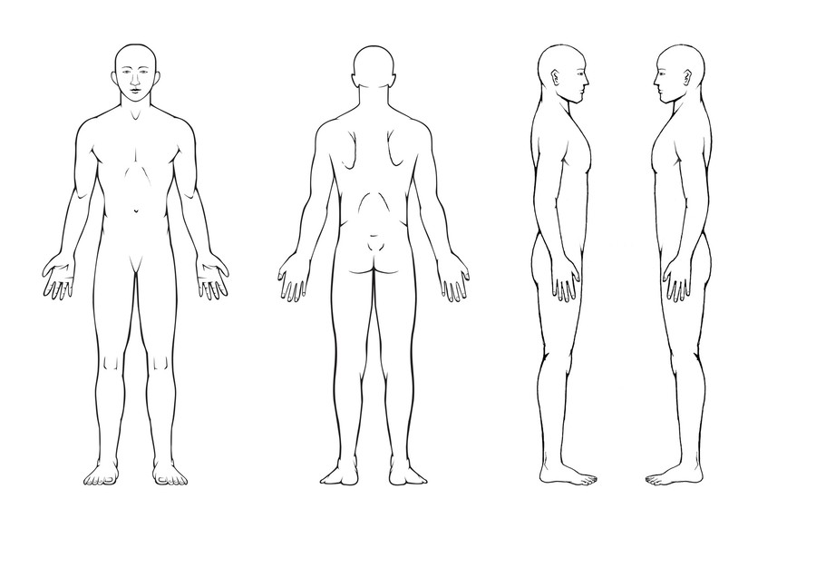
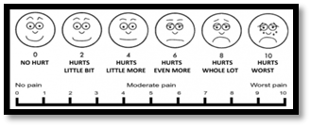

Pain 1 | Pain score | Before procedure | After procedure | 15 min | 30 min | 1 hr. | 2 hr. | 4 hr. | 6 hr. | Next Morning | Week Average | Follow up
Pain 1 | 10
Pain 1 | 9
Pain 1 | 8
Pain 1 | 7
Pain 1 | 6
Pain 1 | 5
Pain 1 | 4
Pain 1 | 3
Pain 1 | 2
Pain 1 | 1
Pain 1 | 0
Pain 2 | Pain score | Before procedure | After procedure | 15 min | 30 min | 1 hr. | 2 hr. | 4 hr. | 6 hr. | Next Morning | Week Average | Follow up
Pain 2 | 10
Pain 2 | 9
Pain 2 | 8
Pain 2 | 7
Pain 2 | 6
Pain 2 | 5
Pain 2 | 4
Pain 2 | 3
Pain 2 | 2
Pain 2 | 1
Pain 2 | 0
Pain 3 | Pain score | Before procedure | After procedure | 15 min | 30 min | 1 hr. | 2 hr. | 4 hr. | 6 hr. | Next Morning | Week Average | Follow up
Pain 3 | 10
Pain 3 | 9
Pain 3 | 8
Pain 3 | 7
Pain 3 | 6
Pain 3 | 5
Pain 3 | 4
Pain 3 | 3
Pain 3 | 2
Pain 3 | 1
Pain 3 | 0

