📋 PRE-PROCEDURE INSTRUCTIONS
PRP Regenerative Therapy
Combined Facet Joint + Intradiscal PRP Injection
Patient Name: |  | Procedure Date:
Spine Levels: |  | Arrival Time:
Physician: |  | Driver:

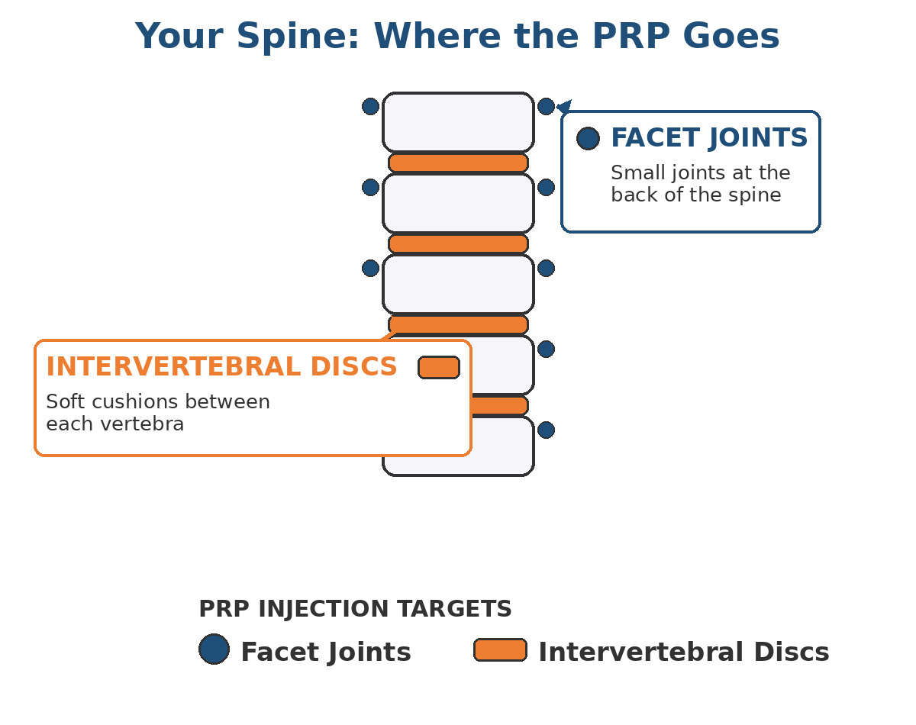 | 🩺 ABOUT YOUR PROCEDURE  You are scheduled for a Platelet-Rich Plasma (PRP) injection that treats two spinal structures the same day:  - 🔵 Facet joint PRP — into the small joints behind your spine  - 🟠 Intradiscal PRP — into the cushion (disc) between vertebrae  PRP is concentrated from your own blood and releases growth factors that trigger your body's natural healing response. ⏱️ The whole appointment takes about 45–75 minutes.

⚠️ CRITICAL: NSAIDs WILL RUIN YOUR PRP
Anti-inflammatory medications block the healing response PRP is designed to trigger. Taking them at the wrong time can make your procedure ineffective.
🛑 STOP all NSAIDs 7 days BEFORE your procedure and do not resume for at least 4 weeks AFTER.
💊 Includes: ibuprofen (Advil, Motrin), naproxen (Aleve, Naprosyn), meloxicam (Mobic), celecoxib (Celebrex), diclofenac (Voltaren — including topical gel and patches), aspirin (unless cardiac), Toradol, indomethacin, and any other NSAID.

📅 Two Weeks Before
🛑 Medications to STOP
- 💊 All NSAIDs: stop 7 days prior. Includes topical (Voltaren gel, Pennsaid).
- 💊 Oral steroids (prednisone): stop 4 weeks prior if possible — call us if you cannot.
- 💉 Steroid injections elsewhere: none for 4 weeks before or after.
- 🌿 Herbal blood thinners: fish oil, vitamin E (>400 IU), turmeric, ginkgo, garlic supplements, ginseng, CBD. Stop 7 days prior.
🩸 Blood Thinners — DO NOT STOP
If you take warfarin (Coumadin), Plavix, Eliquis, Xarelto, Pradaxa, Brilinta, Effient, or daily cardiac aspirin, contact the prescribing physician AND our office BEFORE making changes. We coordinate the safest plan with your cardiologist.
🌱 Lifestyle Prep
- 💧 Hydrate: 64+ oz of water daily for 3 days before.
- 🍷 No alcohol for 48 hours before.
- 🚭 No nicotine — strongly encouraged to quit. Minimum: 48 hours before and 2 weeks after.
- 🍎 Eat well, prioritize protein and rest.
🌙 The Day Before
✅ Confirm Your Plan
- 🚗 Confirm your driver — a responsible adult MUST drive you home. No rideshare alone, no bus.
- 💧 Keep hydrating — at least 64 oz of water.
- 🍽️ Eat a normal dinner. You may eat and drink normally tomorrow morning unless told otherwise.
- 🚿 Shower with regular soap. No lotions, oils, or perfumes on your back.
- 👕 Lay out loose, comfortable clothing (button or zip-front top is ideal).
- 😴 Get a full night of sleep.
☀️ The Morning Of
🩺 Get Ready
- 🍞 Light breakfast: toast, oatmeal, yogurt — avoid heavy or greasy food.
- 💊 Take your regular morning medications with a small sip of water EXCEPT any we said to hold.
- 🚿 Shower; no lotion, powder, or fragrance on back, neck, or hips.
- 👔 Wear loose, two-piece clothing. Leave jewelry and valuables at home.
- ⏰ Arrive 30 minutes before your procedure time.
🎒 What to Bring
☐ 🪪 Photo ID and insurance card
☐ 📋 Complete, current medication list (with doses)
☐ 💿 Imaging discs (MRI/CT) the physician requested
☐ 📄 This instruction sheet
☐ 🚗 Your driver (must stay on site or be reachable for pickup)
☐ 🛋️ Optional: a pillow or cushion for the car ride home

🏥 What to Expect at the Center
- 📝 Check-in & vital signs: medication review, consent confirmation, final questions.  - 🩸 Blood draw: ~30–60 mL from your arm, processed in a centrifuge (15–20 min).  - 🛏️ Positioning: you lie face-down on a fluoroscopy table; pillows for comfort.  - 🧼 Skin prep: sterile antiseptic and drape. | - 🔵 Facet joint injections (live X-ray guidance) first — minor pressure only.  - 🟠 Intradiscal injection: needle into disc center with contrast confirmation.  - 💊 Antibiotics: given IV and/or intradiscally to prevent disc infection — tell us about ANY allergies!  - 🛌 Recovery: 30–45 min of monitoring before discharge.

ℹ️ ABOUT SEDATION
PRP procedures are typically performed with local anesthetic only and minimal-to-no IV sedation. This is intentional — most sedatives and large amounts of anesthetic can dilute or inactivate the PRP and reduce its effectiveness. If sedation has been arranged for you, you will receive separate NPO (nothing-by-mouth) instructions.

📞 QUESTIONS? GET IN TOUCH
📞 Phone: (314) 557-3472 (after hours, calls forward to the on-call physician)
✉️ Email: mgmt@onlinespinecare.com
🌐 Website: www.onlinespinecare.com
📍 Address: 16216 Baxter Road, Suite 110
🚨 For life-threatening emergencies, always call 911.
These instructions are general guidance and do not replace the individualized advice of your S.P.I.N.E. Center physician. If any instruction conflicts with what your physician has told you, follow your physician's direction.

